- Log into the customer portal and click the Add Request button (top right corner)
- At the top of the screen that is opened, fill out the following:
  - Your PO (in field “Customer PO”)
  - OPTIONAL: Any specific or special notes you would like us to know about your sample or order (in field “Order Notes”)
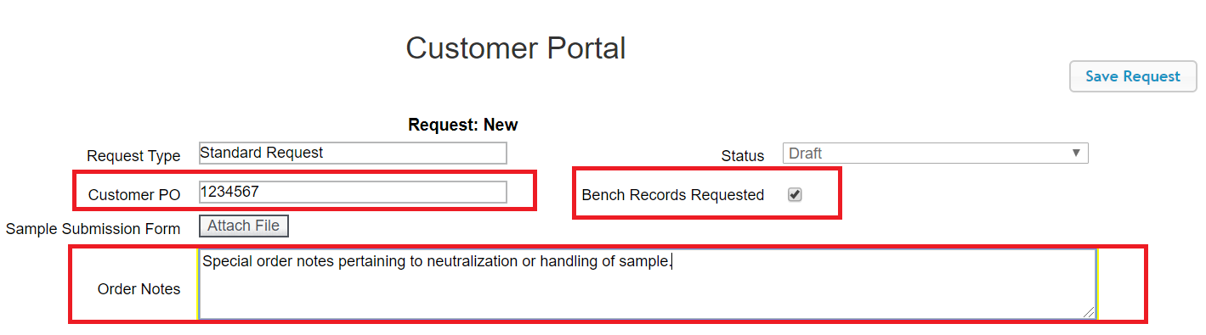
  - If you would like your bench records for this order, check the Bench Records Requested box
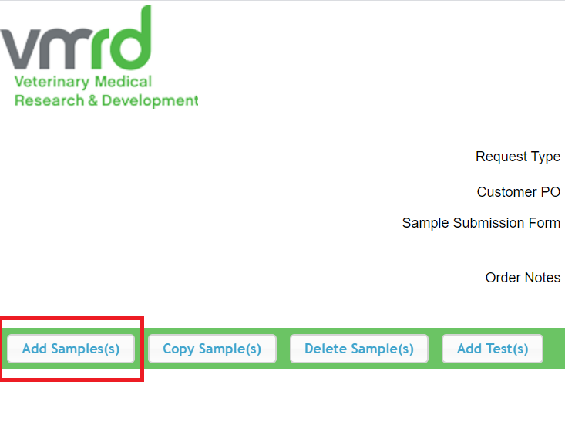
- Once the above fields are completed, click the Add Sample(s) button
- The Add Sample dialog box will appear. Fill out the number of samples you wish to add, and select the type of sample. In the example below, we will add one Animal Origin Product Sample.
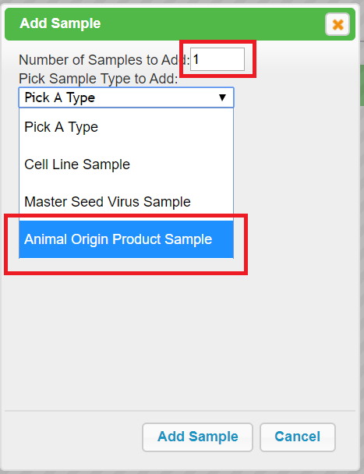
Don’t forget to click “Add Sample” when you are done!
- The sample grid can now be populated. Fill out all required fields (shaded in red). You must double click within a field to begin typing in that cell. Hit enter or the designated “save” button for that field to complete that entry.
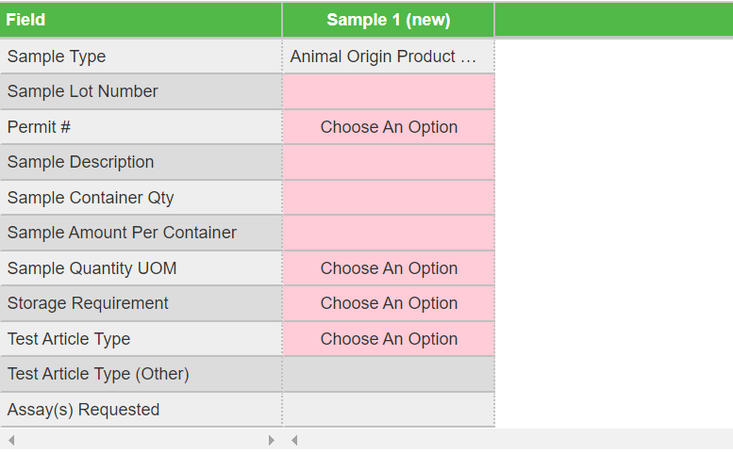
TIP: This is the number of containers you are shipping
TIP: This is the Unit of Measure for the quantity designated in the containers (i.e. grams (g), milliliters (mL), etc)
TIP: This is the quantity in each container
- Repeat the sample addition process until all samples are populated for your order
- Now it’s time to add some tests! Click the Add Test(s) button (as shown).
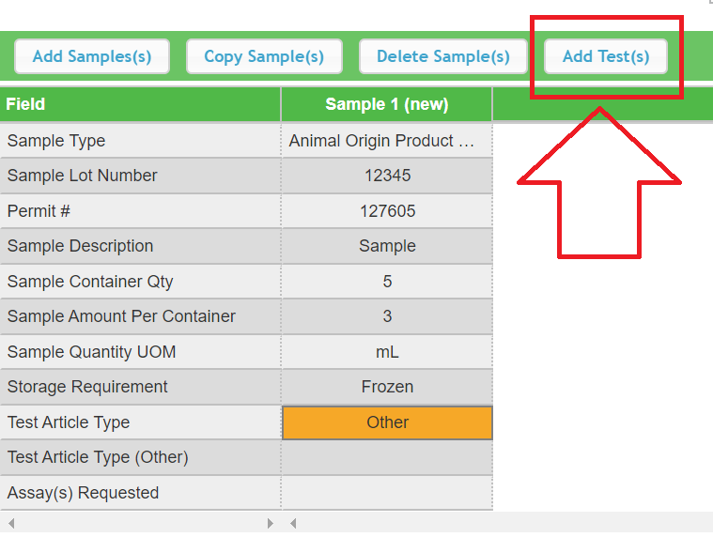
- A list of tests will appear. Select one or more tests to add to the sample, then select Add and Select Tests. This will add the tests selected to the existing sample(s) on the grid. If you have entered multiple samples requiring the SAME tests, this button will add the tests to ALL the samples you have entered.
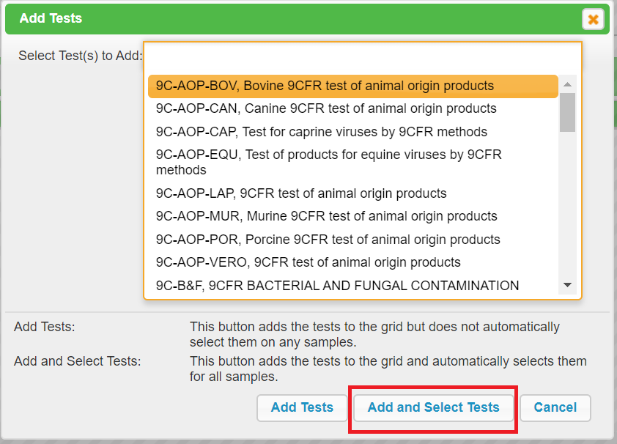
- In the example below, a 9C-AOP-BOV was added to a sample, which automatically includes a 9C-AOP-VERO.
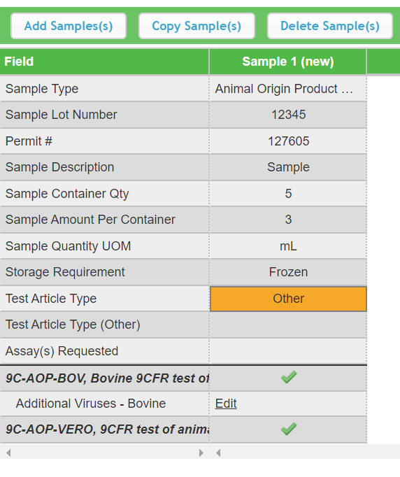
- But wait…not all my samples need the same tests! Don’t worry! Select all the tests you need to order followed by the Add Tests button – it’s right next to the Add and Select Tests button. A grid format will shows up UNDER all your samples. Check the boxes for each test that applies to a given sample and voila! All your samples have had the correct tests assigned.
When tests are originally populated to the grid, the boxes will be unchecked, as indicated by the black arrow. Check the tests required for each sample by clicking in the box. Once selected, the box will change to a green check mark, as indicated by the red arrow. Only those tests “checked” (selected) will be associated with the sample upon submission.
- When your order is complete, click Submit Request
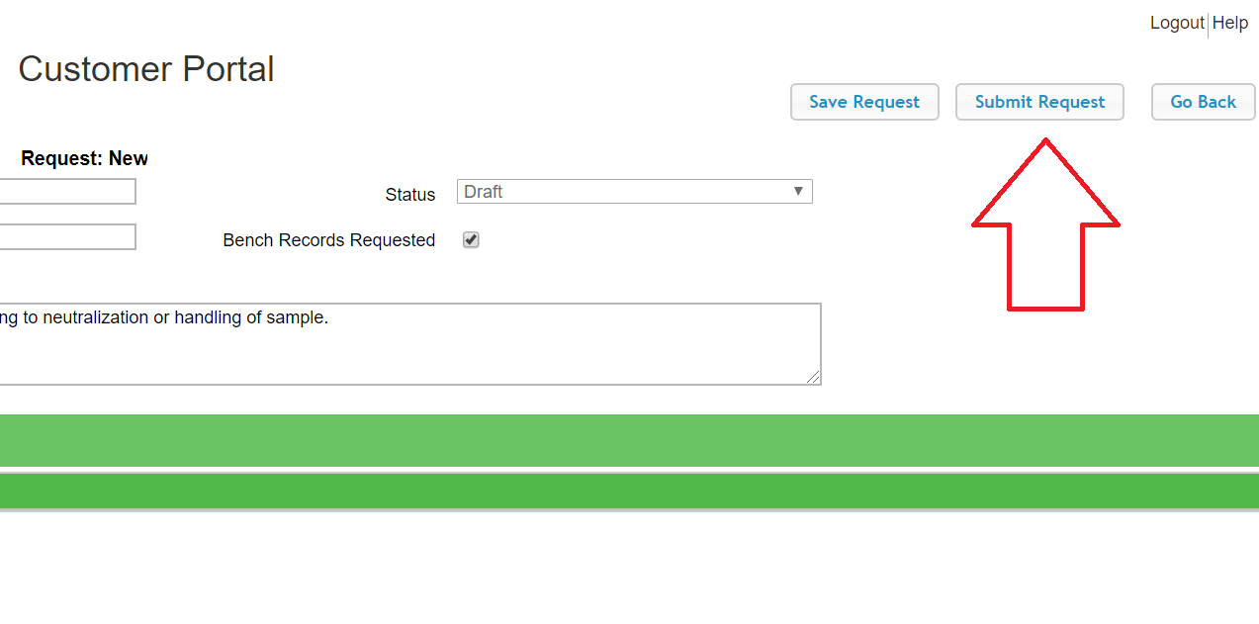
- The request will be submitted and you will have the opportunity to print a submission form. 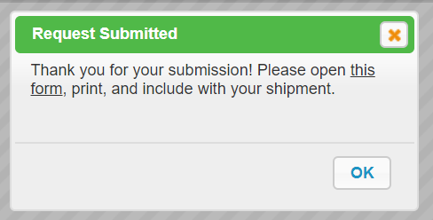
- Print the form and include it with the sample that you ship to VMRD.

